Just wanted to let you know about this amazing event which will take place March 8.
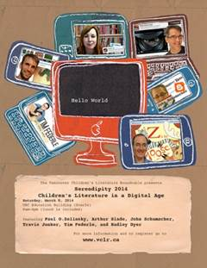
Serendipity 2014: Children’s Literature in a Digital Age
Saturday, March 8 2014
UBC Education Building: 2125 Main Mall
8am-4pm (lunch is included)
From practical advice on using literature-based apps with children to learning how authors and illustrators are using social media and electronic publishing, Serendipity 2014 is a must-attend event for educators, librarians, researchers and literature lovers looking to the future of books for young people.
We have invited presenters that are not only at the forefront of the rapidly-evolving world of technology and children’s books, but are also dynamic, engaging and will leave you inspired and full of ideas:
- Paul Zelinsky (@paulozelinsky): Caldecott-winning illustrator of over two dozen books
- Arthur Slade (@arthurslade): Governor-general’s award-winning author
- John an style='font-size:12.0pt;font-family:"Garamond","serif";mso-fareast-language:EN-CA'> (@MrSchuReads): Library Journal Mover and Shaker, elementary school teacher-librarian, blogger, 2014 Newbery Committee member
- Travis Jonker (@100scopenotes): School Library Journal blogger, elementary school teacher-librarian, 2014 Caldecott Committee member
- Tim Federle (@TimFederle): Author of Better Nate Than Ever and the forthcoming sequel Five, Six, Seven, Nate! (January 2014)
- Hadley Dyer (@hedyer): Winner of the Information Book Award for Potatoes on Rooftops: Farming in the City
EARLY BIRD REGISTRATION until January 31, 2014: Members $150, Non-Members $165, Students $75
REGULAR REGISTRATION starts February 1, 2014: Members $200, Non-Members $215, Students $100

